Tahoe Elementary
Parent Participation
Preschool

The Parent Participation Preschool Program is designed to foster
social and emotional development,
collaborative play, and self-directed learning through a variety of
developmentally appropriate experiences.
Preschool is a great way to get your child Kinder Ready!

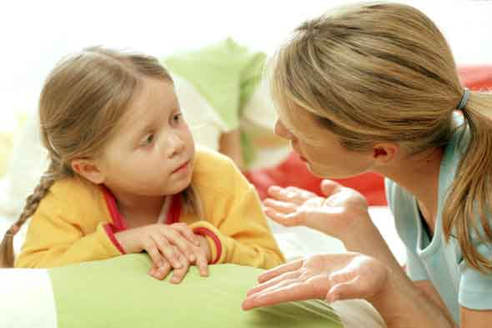

Cost Per Semester
Preschool AM ($475) M-Th 9:00-11:30AM
Preschool PM ($575) M-F 12:00-2:30PM
Toddler Class ($175) Friday 9:30-11:30AM

To attend preschool children need to be 3 and fully potty trained
NOW ENROLLING
Call 916-395-4753
Visit us on Facebook at SCUSD Parent Participation Preschool

Located at seven Sacramento City Schools
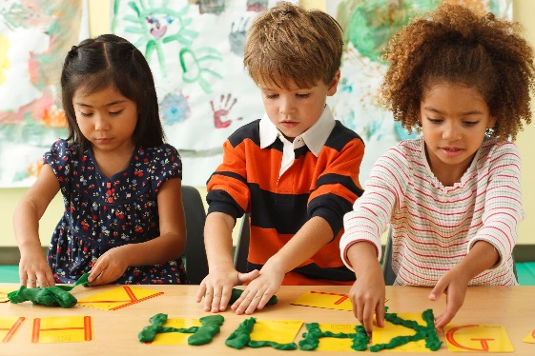
Building a brighter future for parents and children

